Tin Nguyen

ID: 41873150

Project 1: Satellite Simulator

Queue generated with Country and Package Type requested (**this is not going to any channels yet**):

Japan requesting package type 4 cost 500 dollar

USA requesting package type 3 cost 400 dollar

Switzerland requesting package type 4 cost 500 dollar

Japan requesting package type 3 cost 400 dollar

Japan requesting package type 3 cost 400 dollar

Switzerland requesting package type 2 cost 350 dollar

Switzerland requesting package type 2 cost 350 dollar

Germany requesting package type 2 cost 350 dollar

USA requesting package type 3 cost 400 dollar

Switzerland requesting package type 2 cost 350 dollar

Germany requesting package type 1 cost 210 dollar

USA requesting package type 3 cost 400 dollar

Japan requesting package type 1 cost 210 dollar

Germany requesting package type 4 cost 500 dollar

Germany requesting package type 2 cost 350 dollar

Switzerland requesting package type 4 cost 500 dollar

Japan requesting package type 3 cost 400 dollar

USA requesting package type 1 cost 210 dollar

USA requesting package type 4 cost 500 dollar

USA requesting package type 4 cost 500 dollar

Germany requesting package type 2 cost 350 dollar

Germany requesting package type 1 cost 210 dollar

China requesting package type 2 cost 350 dollar

China requesting package type 2 cost 350 dollar

Switzerland requesting package type 4 cost 500 dollar

This is country go on channel A for 48 hours: (1 country name for 1 hours)

Japan Japan Japan Japan Japan Japan Japan Japan Japan Japan Japan Japan Japan Japan Japan Japan Japan Japan Japan Japan Germany Germany Germany Switzerland Switzerland Switzerland Germany Japan Germany Germany Germany Germany Germany Germany Germany Germany Germany Germany Germany Germany Germany Japan Japan Japan Japan Japan Germany USA

This is country go on channel B for 48 hours: (1 country name for 1 hours)

USA USA USA USA USA Switzerland Switzerland Switzerland Switzerland Switzerland Switzerland Switzerland Switzerland Switzerland Switzerland Switzerland Switzerland Switzerland Switzerland Switzerland Switzerland USA USA USA USA USA USA USA USA USA USA Switzerland Switzerland Switzerland Switzerland Switzerland Switzerland Switzerland Switzerland Switzerland Switzerland USA USA USA USA USA USA Germany

**NO COUNTRY OCCUPIES 2 CHANNEL AT THE SAME TIME!!!**

Index reference **(1-USA 2-China 3-Germany 4-Japan 5-Switzerland)** – needed for graph

This is country go on **channel A** for 48 hours: (1 number represents 1 hour)

4 4 4 4 4 4 4 4 4 4 4 4 4 4 4 4 4 4 4 4 3 3 3 5 5 5 3 4 3 3 3 3 3 3 3 3 3 3 3 3 3 4 4 4 4 4 3 1

This is country go on **channel B** for 48 hours:

1 1 1 1 1 5 5 5 5 5 5 5 5 5 5 5 5 5 5 5 5 1 1 1 1 1 1 1 1 1 1 5 5 5 5 5 5 5 5 5 5 1 1 1 1 1 1 3

PLOT NEXT PAGE

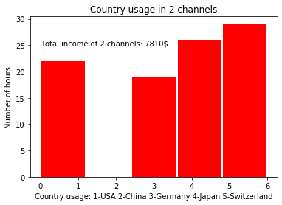

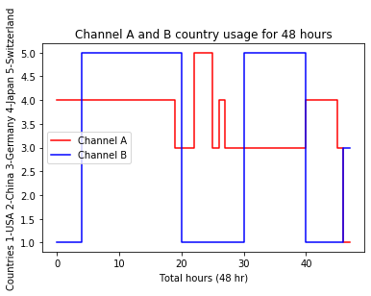

From Python:

**This is how many hours USA use: 22**

**This is how many hours China use: 0**

**This is how many hours Germany use: 19**

**This is how many hours Japan use: 26**

**This is how many hours Switzerland use: 29**